الجمهورية اللبنانية
الاسم والشهرة:--------------------
رقم المرشح :----------------------

رقم المرشح :----------------------
وزارة التربية والتعليم العالي الإمتحانات الرسمية لشهادة الإمتياز الفني
المديرية العامة للتعليم المهني والتقني لدورة عام 2021 الثانية
=============
الإختصاص والرمز : المعلوماتية الإدارية (23106)
المادة : البحث العملاني المعدل : (8)
المستندات المسموح بها: لا شيء المدة : ساعة ونصف
الإجابات على "كراس الإجابة"

Treat the following questions:

- Choose the correct answer: (1pt/ correct answer)

- In graphical method, the restriction on number of variables is:  - =2  - more than 3  - = 3  - None of the above | - In case of an unbalanced problem, what is the shipping cost coefficients that must be assigned to each created dummy factory or warehouse?  - very high positive costs  - very high negative costs  - 1  - 0
- Assuming the objective is :  MAX Z=x+5y  With the following constraints:  5x - y < = 15  -x + 3y ≤ 6  2y - x ≥ 5  What is the used method to find Z?  - Simplex method.  - M method.  - Transportation method.  - None of the above | - Assuming the objective is:  MIN Z=X1+2X2+3X4  With the following constraints:  -X1 + 2X2+4X3+2X4 ≤ 11  3X1 + 2X2-4X4 ≤ 22  X1, X2+X3+X4≥0  What is the used method to find Z?  - Graphical method  - Simplex method  - Transportation method  - None of the above
- In transportation problem, if the supply is greater than the demand, we should:  - Add a dummy row.  - Add a dummy column.  - Add both dummy row and dummy columns.  - Start basic solution without any dummy. | - In simplex method, if MIN Z = 2x1 + 3x2. What is the first selected pivot column?  - Column of x1  - Column of x2  - Column of x1 or column of x2  - Column of x1 and column of x2
- Given the objective :  MAX Z=2x+5y  With the following constraints:  5x - y < = 15  -x + 3y ≤ 6  2y - x ≥ 5  What is the corresponding answer to MAX Z?  - 2x+5y + Ma1 + Ma2  - 2x+5y – Ma1 – Ma2  - 2x+5y + Ma1 + Ma2 + Ma3  - 2x+5y + Ma1 – Ma2 | - Which technique is used in finding a solution for optimizing a given objective, such as profit maximization or cost reduction under certain constraints?  - Quailing Theory  - Waiting Line  - a and b  - Linear Programming
- According to PERT rules, mark the wrong case:  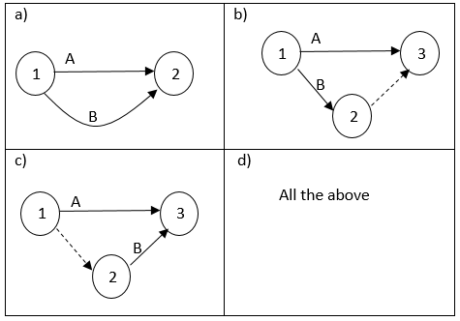 | - An initial transportation solution appears in the table:  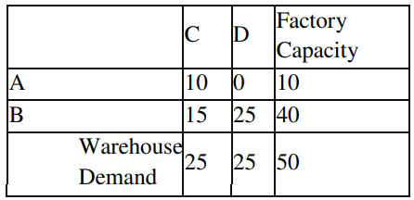  Can this solution be improved if it costs $5 per unit to ship from A to C; $7 per unit to ship from A to D; $8 to ship from B to C; and $9 to ship from B to D?  - Yes, this solution can be improved by $50.  - Yes, this solution can be improved by $100.  - No, this solution is optimal.  - Yes, the initial solution can be improved by $10.

الإختصاص والرمز : المعلوماتية الإدارية (23106)
المادة : البحث العملاني

- Open questions: (2 pts / question)

- Formulate the problem’s constraints according to the following table that represents the daily required materials M1, M2 with their availabilities to produce the products P1, P2

 | M1 | M2
P1 | -1 | 2
P2 | 3 | 0
Available quantities | 60 | 90

- Assuming that the daily profit of P1, P2 is approximately 60$ and 90$. Formulate the objective Z of the problem.

- Find a basic solution (Only a basic solution) using North west Corner method for the following transportation table:
 | D | E | F | Supply
A | 5 | 1 | 7 | 10
B | 4 | 4 | 6 | 60
C | 3 | 2 | 5 | 15
Demand | 35 | 20 | 50

- Find a basic solution (Only a basic solution) using Least Cost method for the following transportation table:
 | D | E | F | Supply
A | 5 | 1 | 7 | 10
B | 4 | 4 | 6 | 60
C | 3 | 2 | 5 | 15
Demand | 35 | 20 | 50

- Find a basic solution (Only a basic solution) using Vogel’s approximation method for the following transportation table:
 | D | E | F | Supply
A | 5 | 1 | 7 | 10
B | 4 | 4 | 6 | 60
C | 3 | 2 | 5 | 15
Demand | 35 | 20 | 50

